Student Name: __________________
Class and Section __________________
Total Points (20 pts) __________________
Due: Wednesday Oct 13, 2010 before the class

Project: Display a Graph

CSCI 1302 Advanced Programming Principles
Armstrong Atlantic State University

Problem Description:

A graph consists of vertices and edges that connect vertices. Write a program that reads a graph from a file and displays it on a panel. The first line in the file contains a number that indicates the number of vertices (n). The vertices are labeled as 0, 1, ..., n-1. Each subsequent line, with the format u x y v1, v2, ..., describes that the vertex u is located at position (x, y) with edges (u, v1), (u, v2), etc. Figure (a) gives an example of the file for a graph. Your program prompts the user to enter the name of the file, reads data from the file, and displays the graph on a panel, as shown in Figure (b).
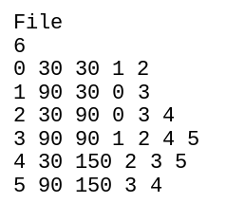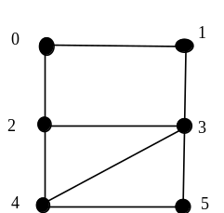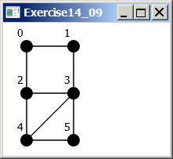
(a) (b)

The program reads the information about the graph and displays it visually.
Analysis:

A graph is a mathematical structure with vertices and edges that connect the vertices. A graph is a very useful tool for modeling real-world problems. This project is to display the graph. The information for the graph is stored in a file. The number of the vertices n is stored in the first line of the file. The vertices are labeled 0, 1, 2, ..., n-1. The format of each subsequent line is u x y v1, v2, ..., which describes vertex u at location (x, y) and u is connected to vertices v1, v2, etc.

Design:

The program should first read the information about the graph from a file. The program prompts the user to enter the file name and read vertices location information into a two-dimensional array named position, where (position[0][0], position[0][1]) is the x- and y-coordinates for vertex 0. For example, in the sample graph, (position[0][0], position[0][1]) is (30, 30). The program reads the edge information into an array of ArrayList named edge (ArrayList is covered in Chapter 11). For example, in the sample graph, edge[0]
Is an ArrayList that contains elements 1 and 2, which indicates that vertex 0 is connected to vertex 1 and vertex 2. position and edge should be created as followed:

int[][] position = new int[n][2];
ArrayList[] edge = new ArrayList[n];

After the graph information are read into position and edge, we can use these information to display the graph. Define a class named GraphView that extends Pane, as follows:

1. data fields position and edge.
2. a constructor that constructs a GraphView object with the specified position and edge.

Draw the UML diagram for GraphView and Exercise14_09Extra:

Coding:

Name your main class Exercise14_09Extra. You code will look like this:

public class Exercise14_09Extra extends Application {

}

class GraphView extends Pane {

}

Two Testing:

- use the sample graph given the Description of the problem.
- use the following graph file to test your program:

7
0 50 45 1 3 4
1 150 25 0 2 3 5
2 250 155 1 4 6
3 150 155 0 1 4
4 30 255 0 2 3 6
5 270 55 1 6
6 60 95 2 4 5

Screen shots:
Include the screen shots for the two tests here:

Must fill in self-evaluation:

- Can your program read the data from the file into position and edge? ________
- Did you draw the UML diagrams for Exercise14_27 and GraphView? _________
- Can you define the GraphView class? _____________
- Can your program display the graph correctly? ____________

Submit the following items:

- Bring a printed copy of this file to the class.

- Compile and Submit to LiveLab (you must submit the program regardless whether it complete or incomplete, correct or incorrect)

